Gilvary research

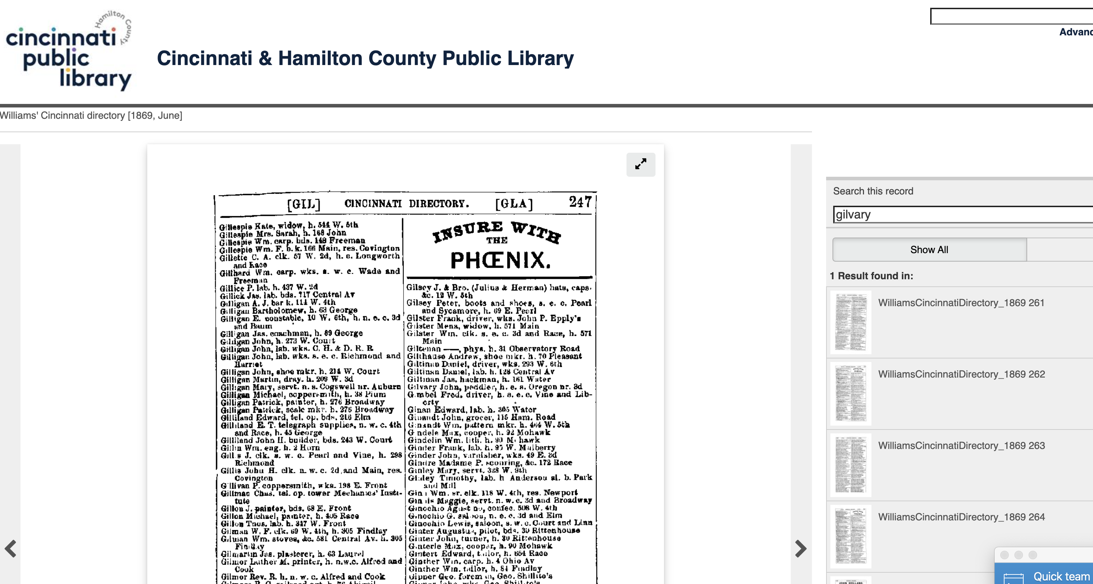

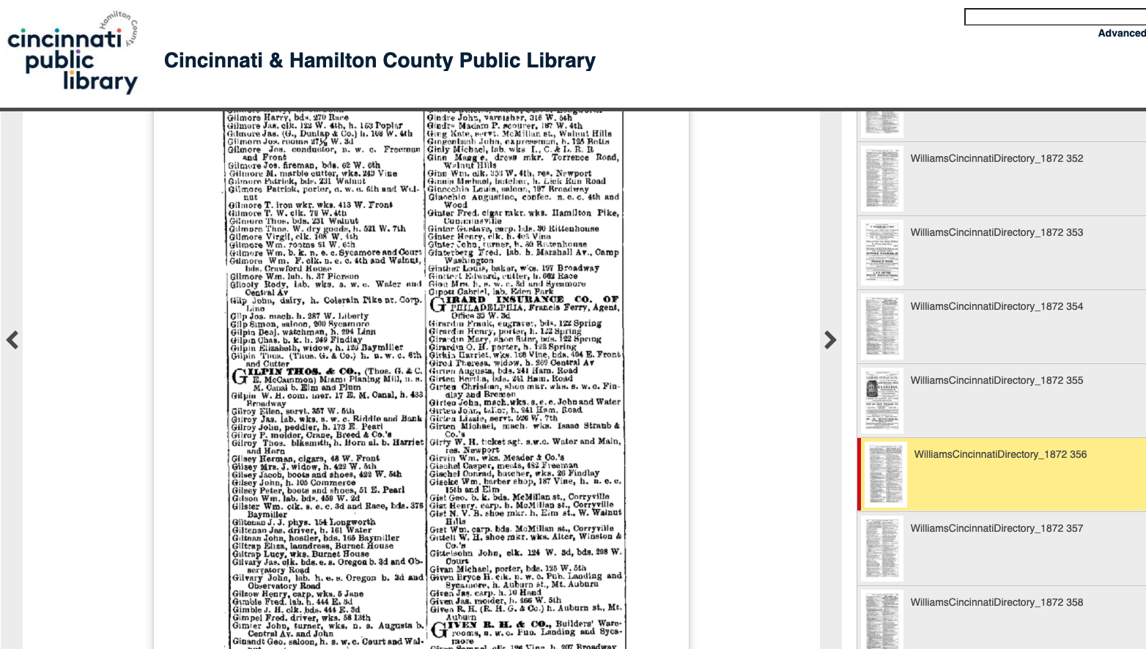

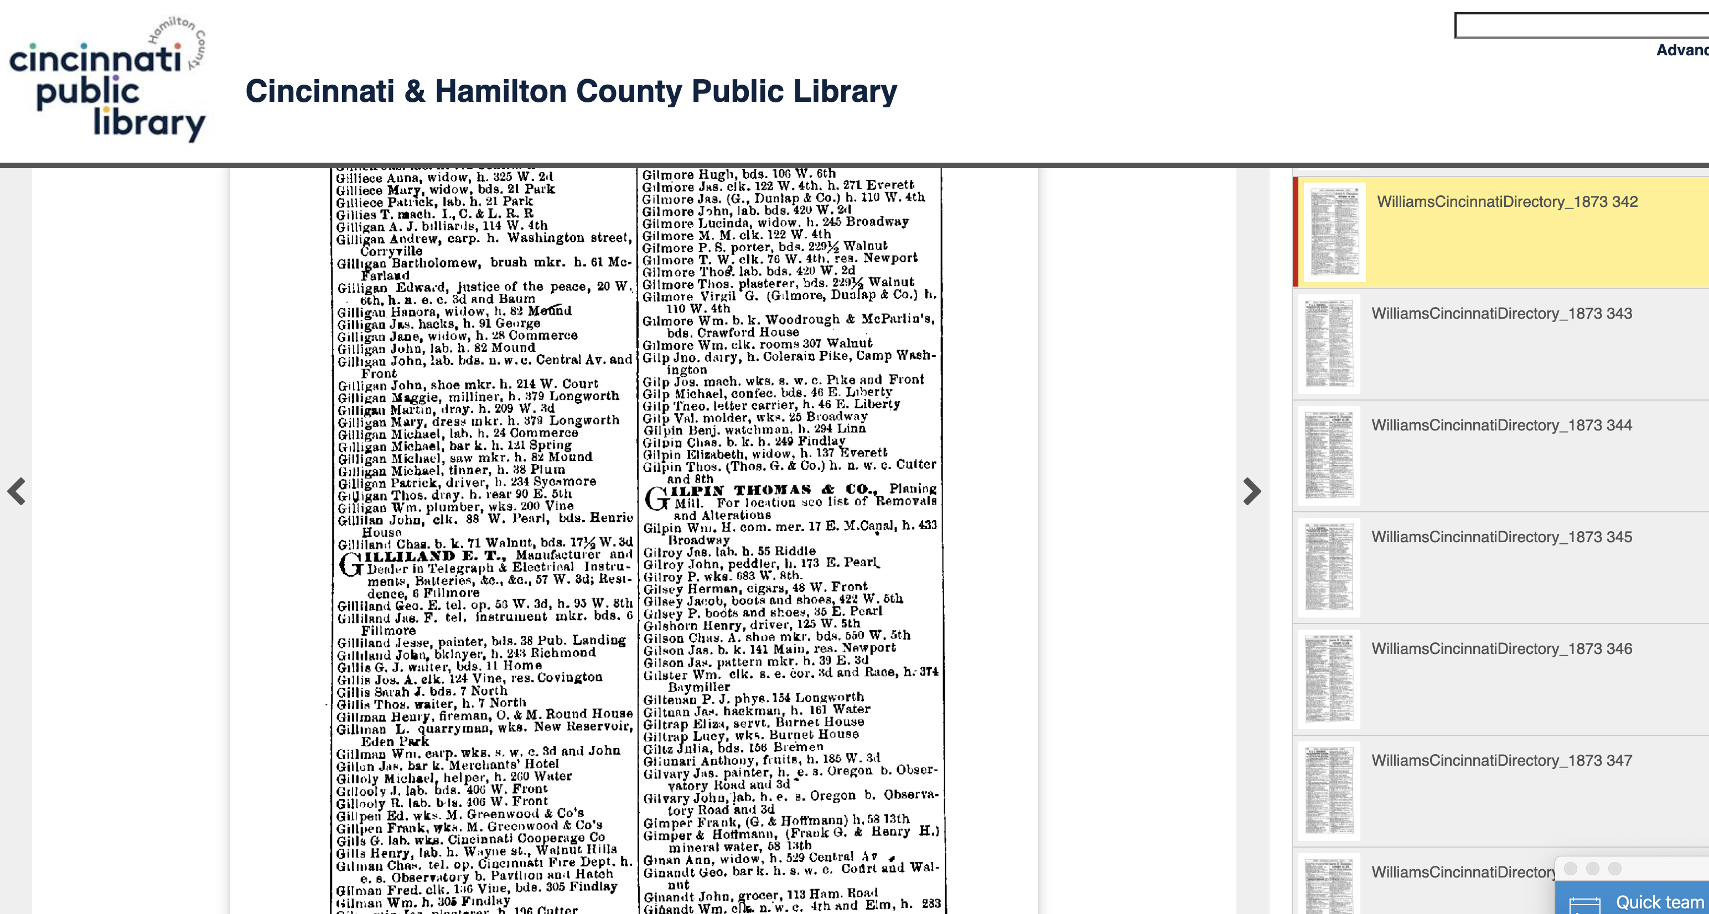

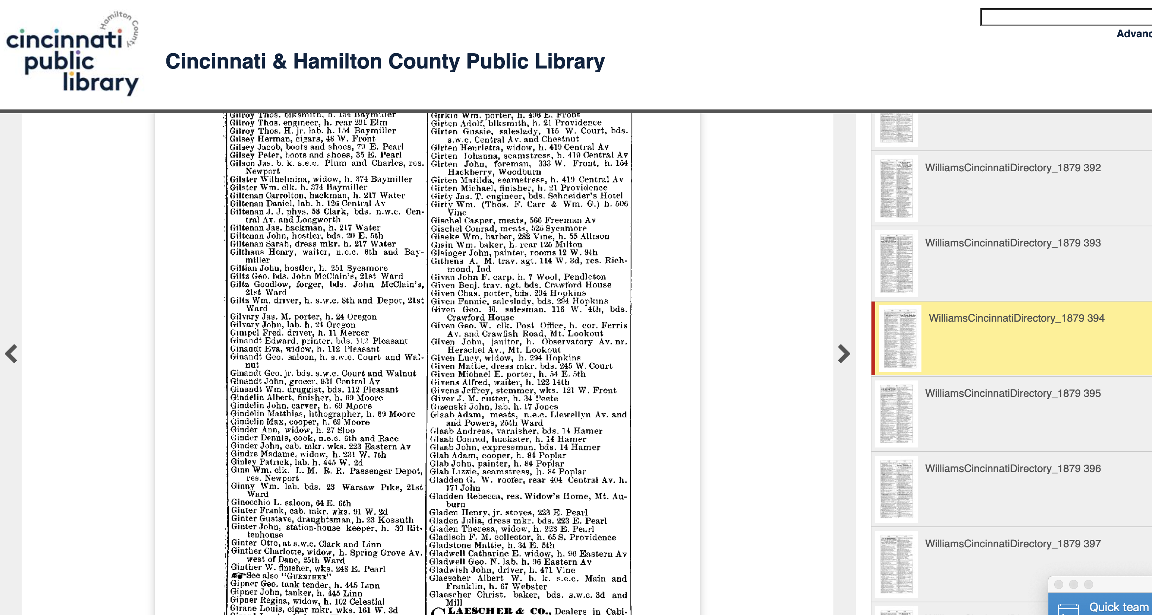

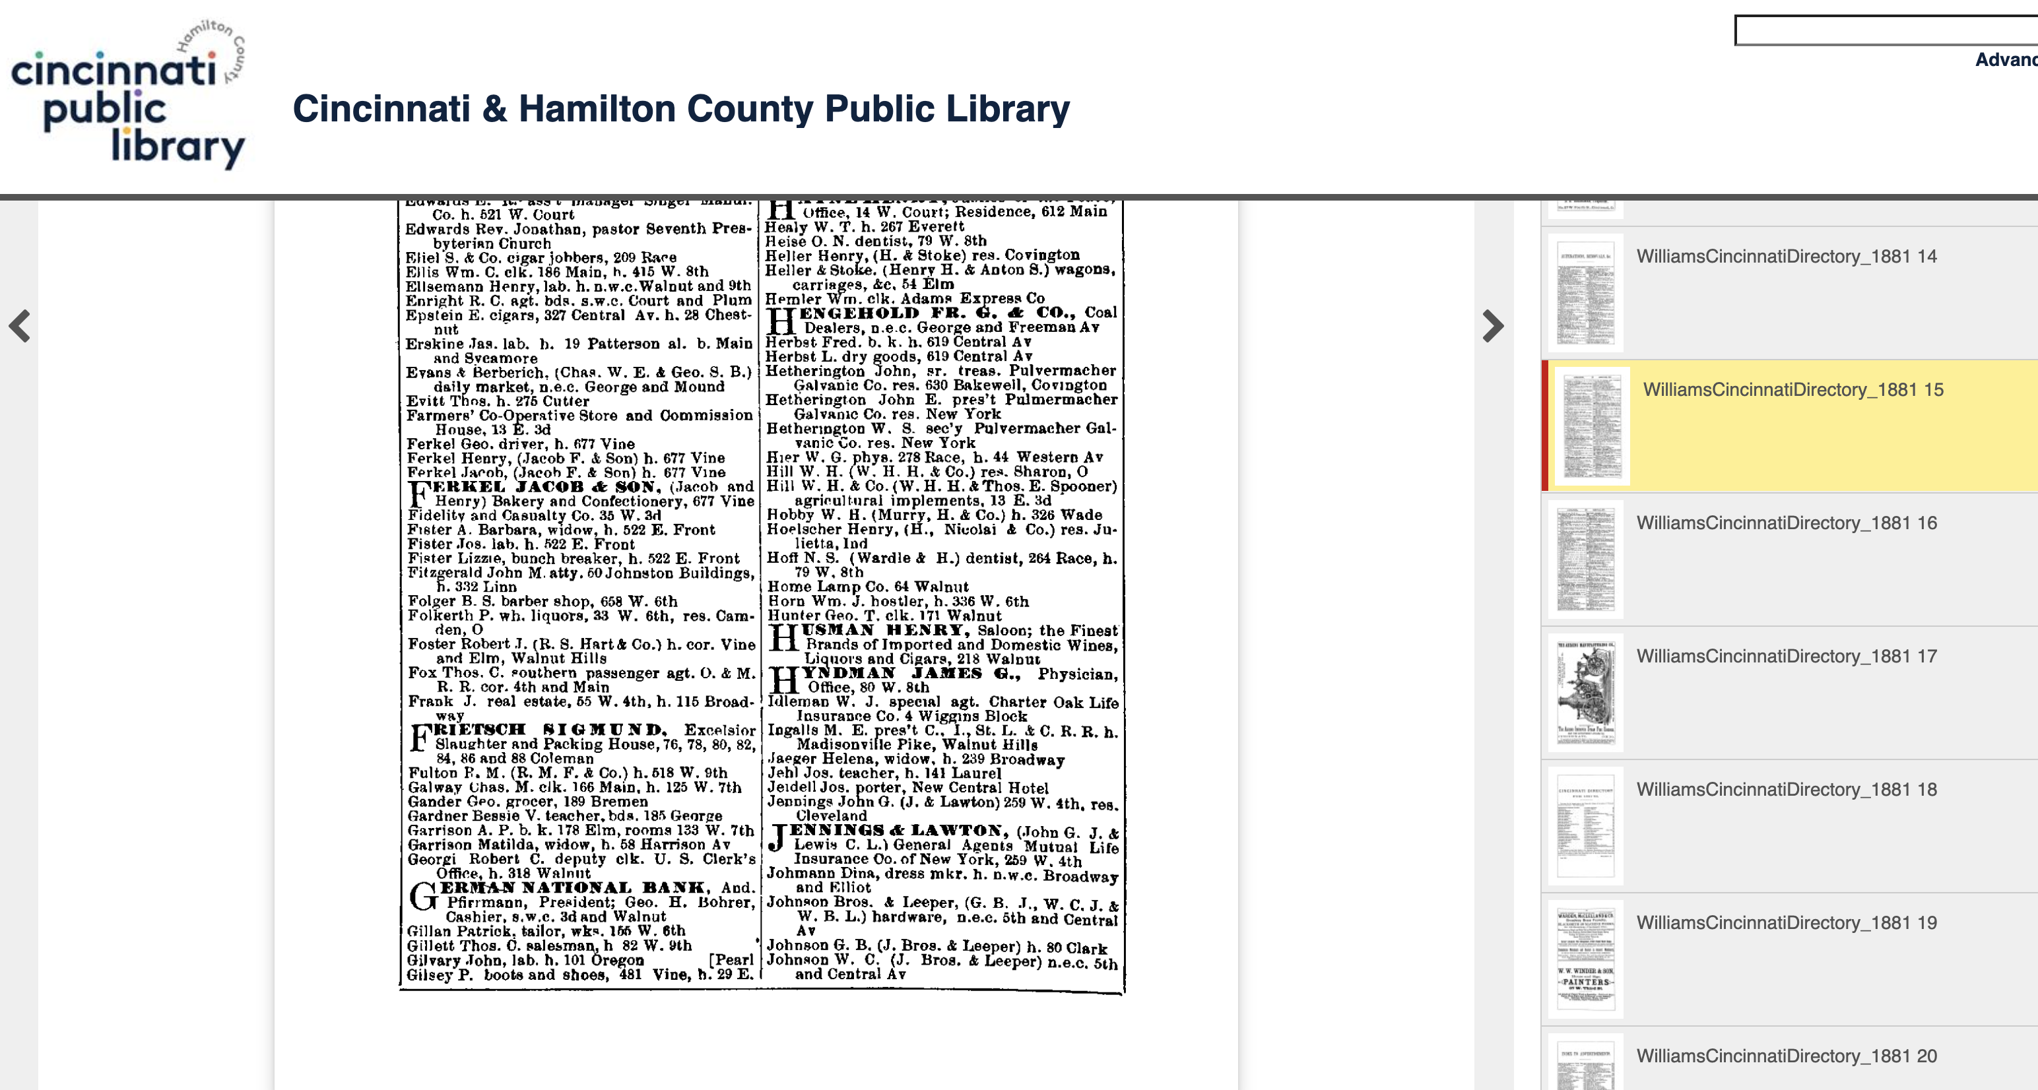

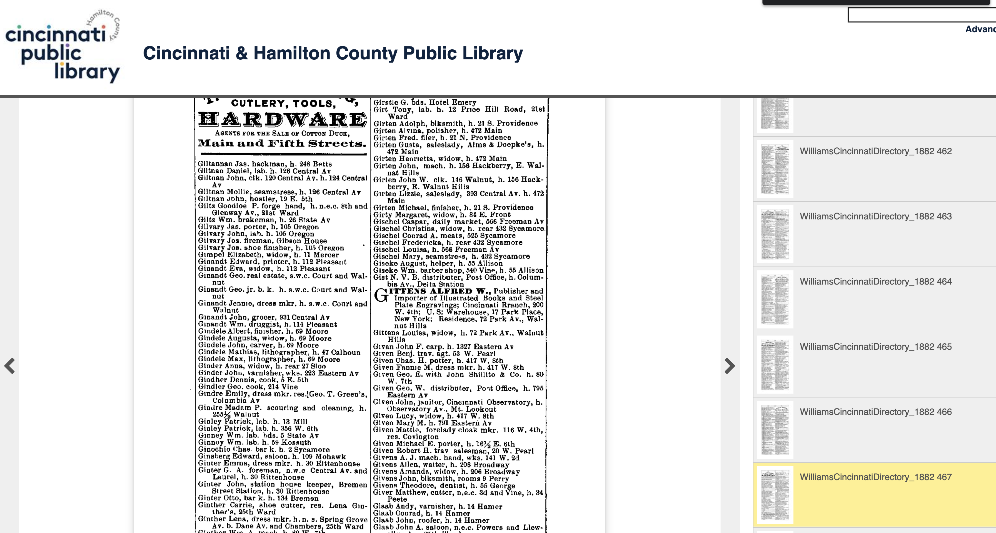

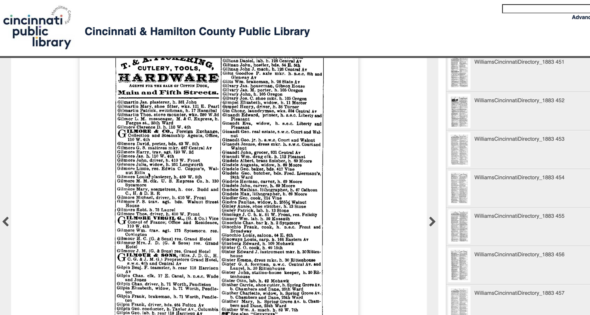

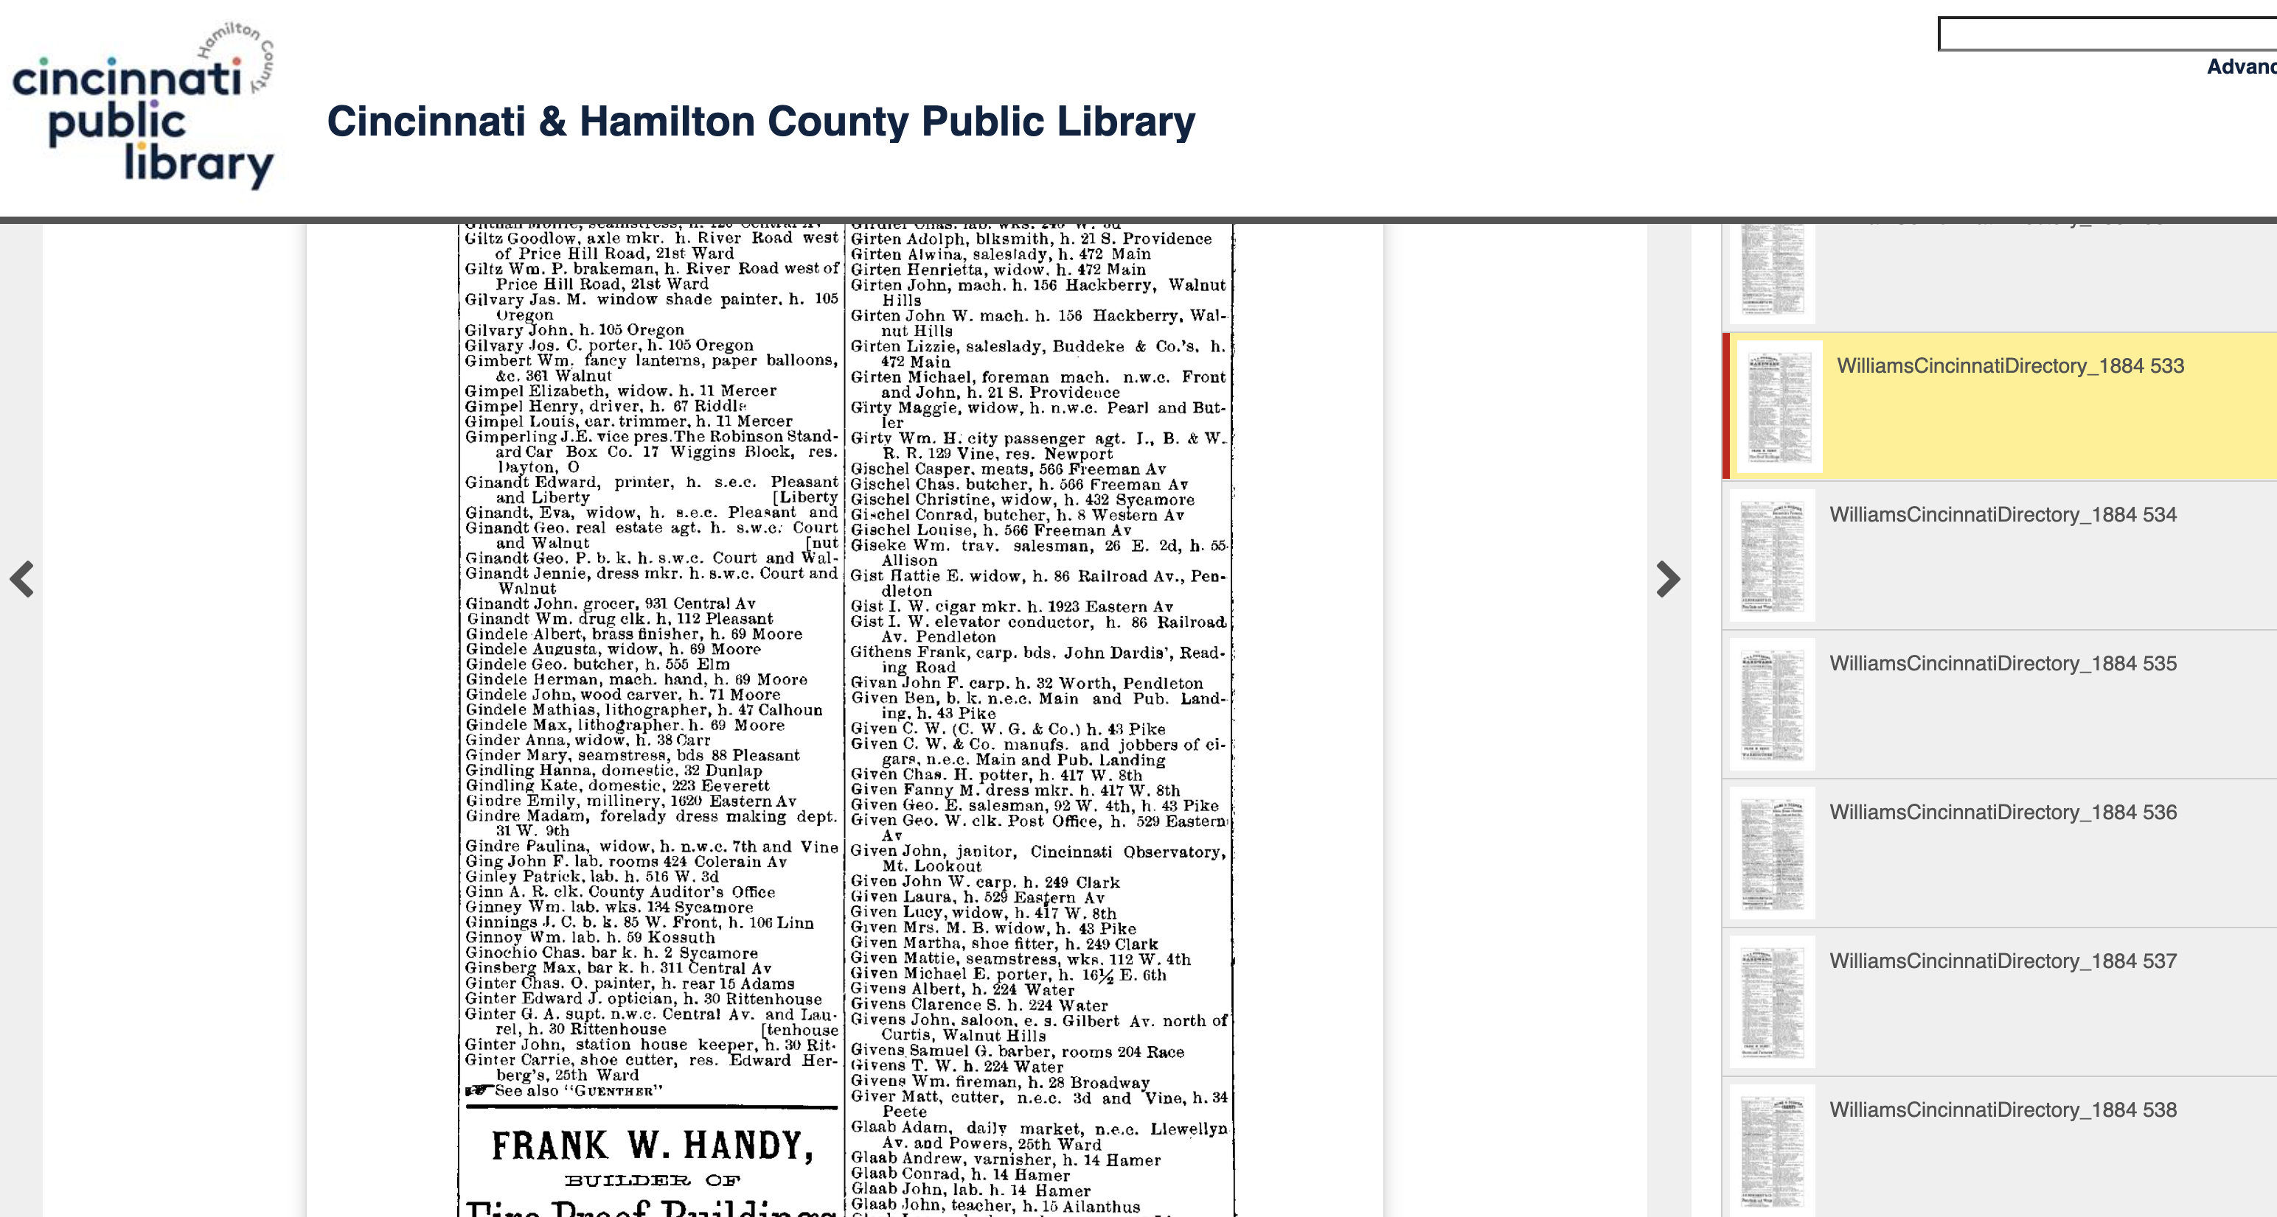

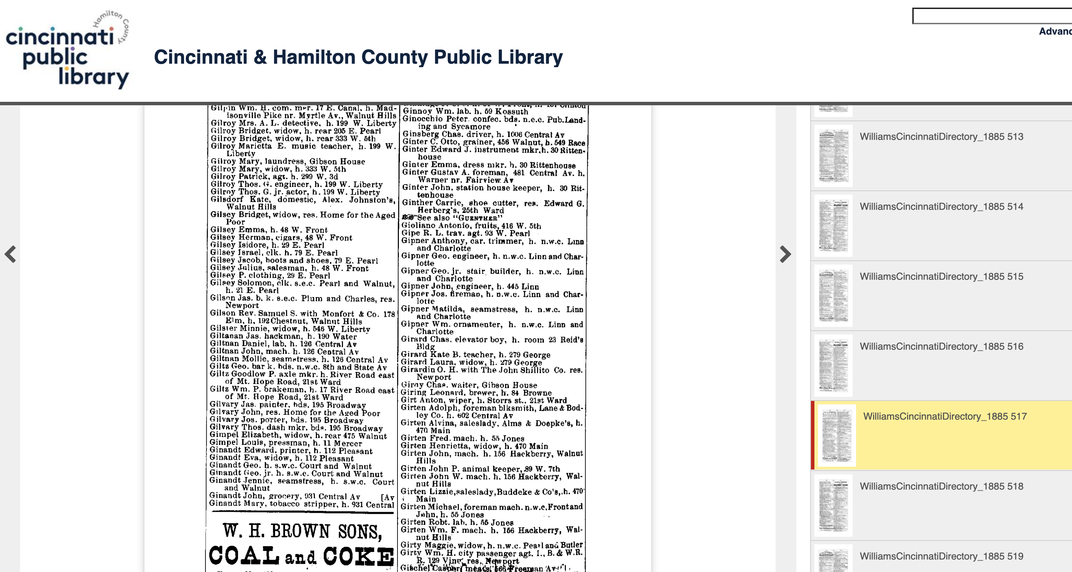

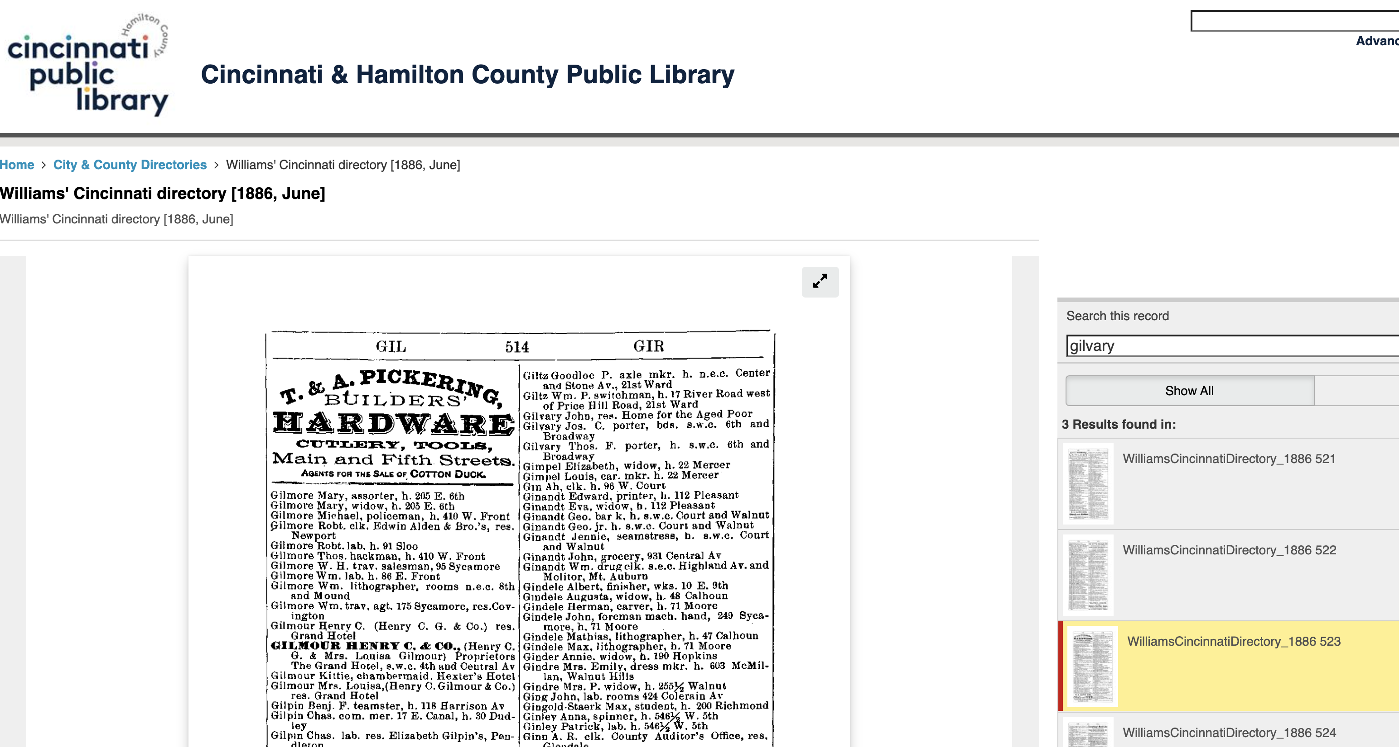

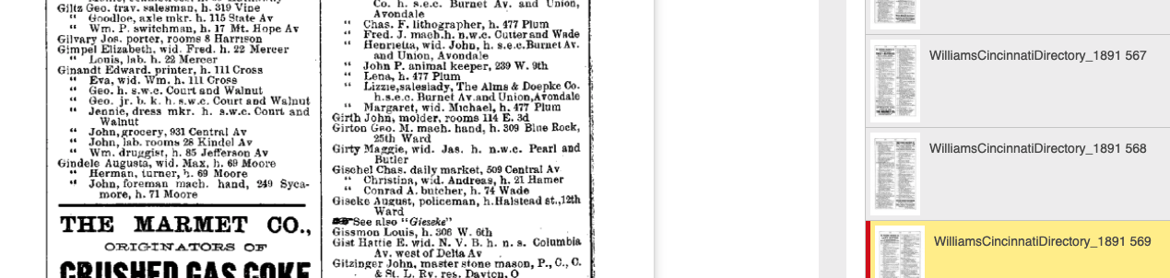

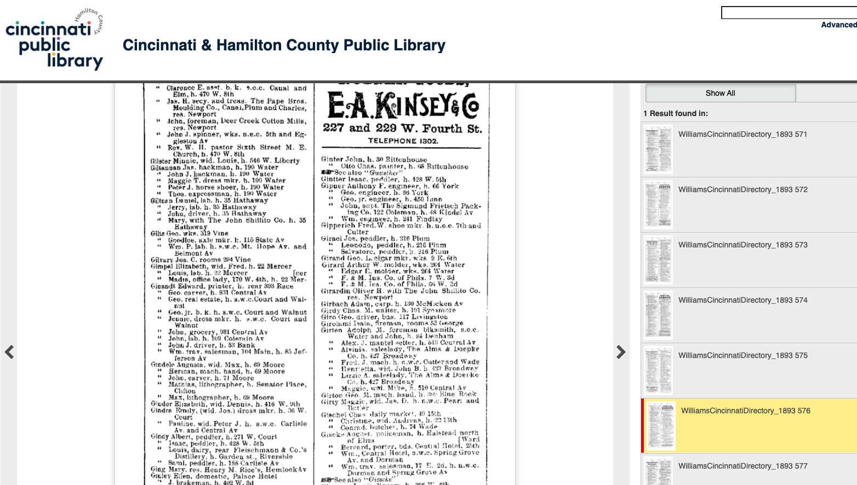

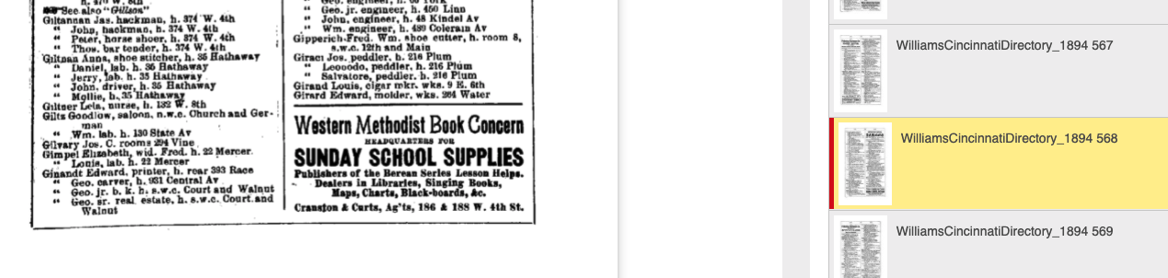

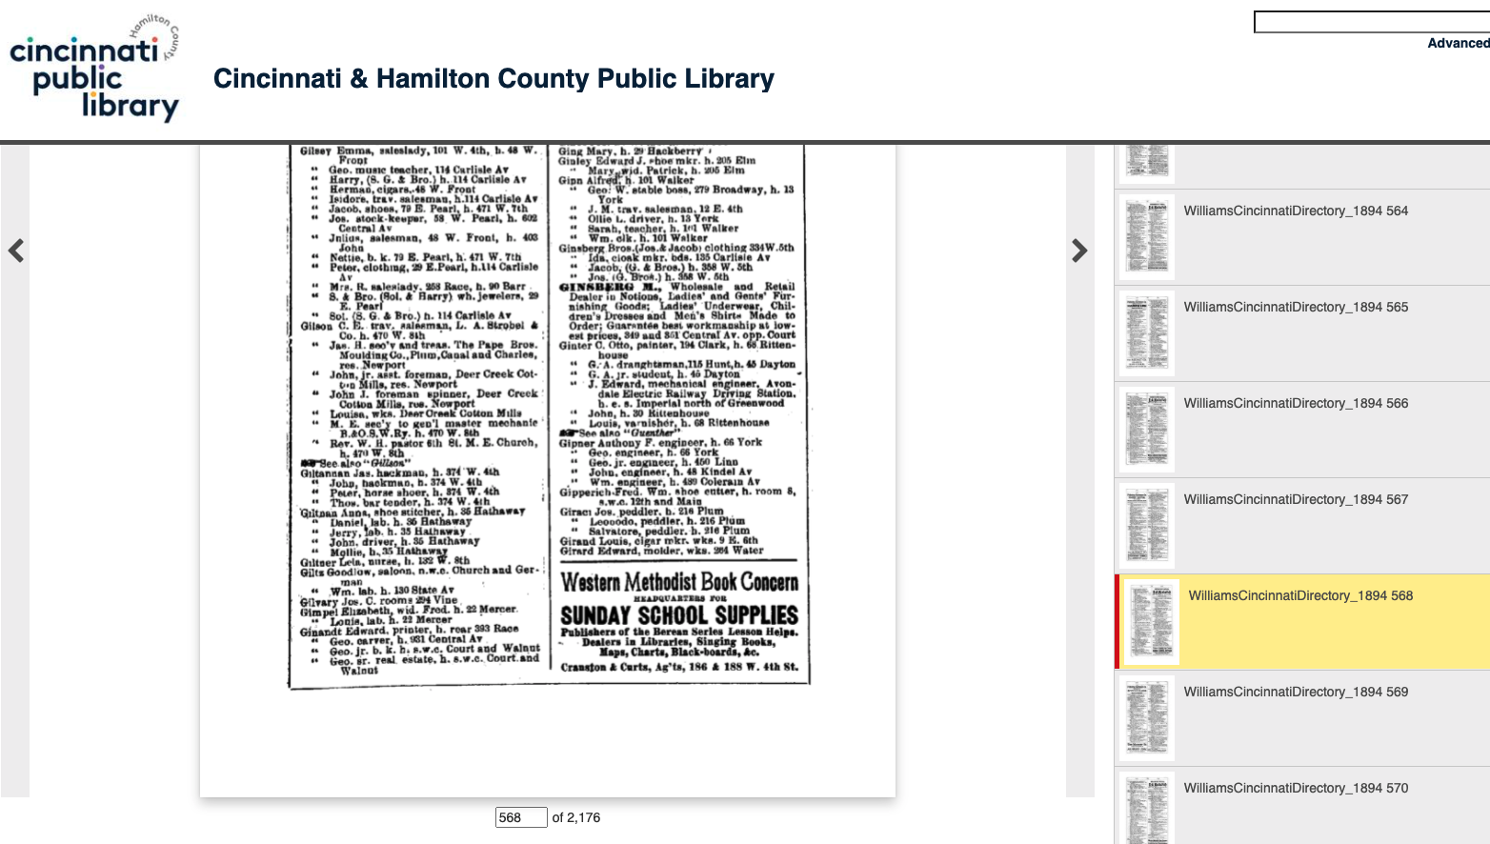





https://www.cincinnatimagazine.com/citywiseblog/bucktown-vanceville-cincinnatis-lost-19th-century-neighborhoods/

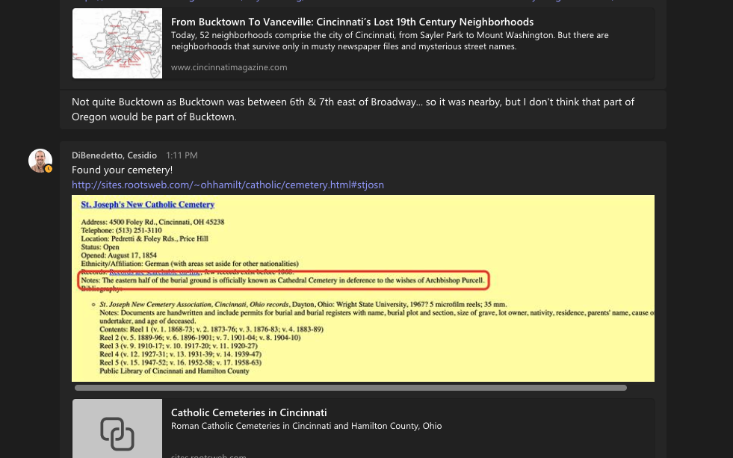

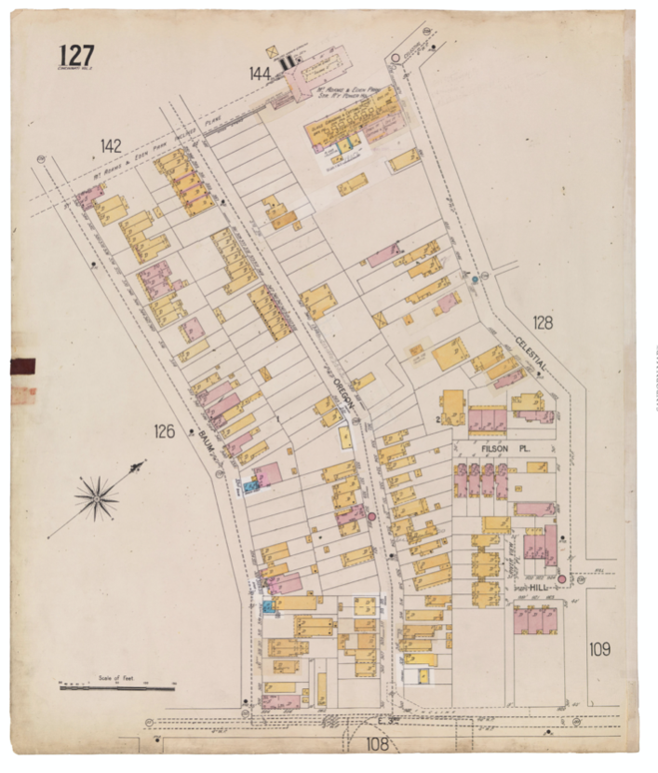







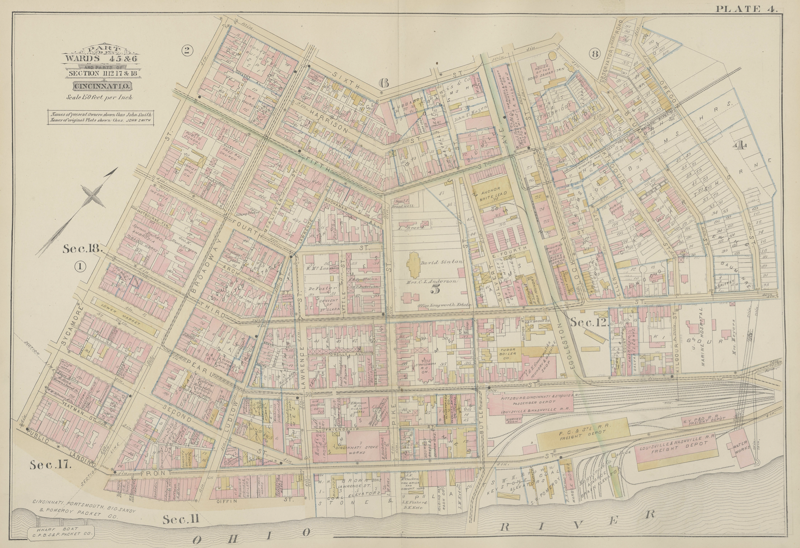

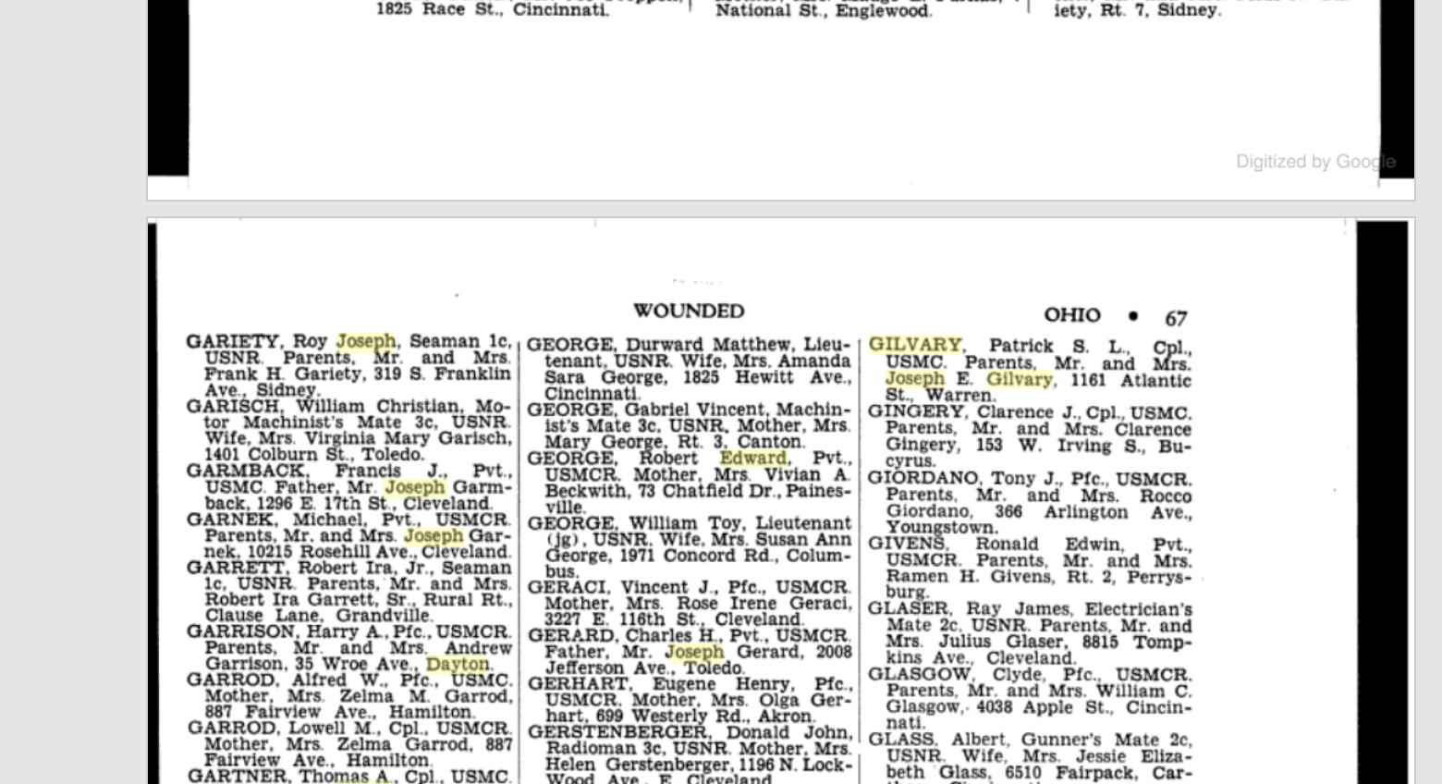

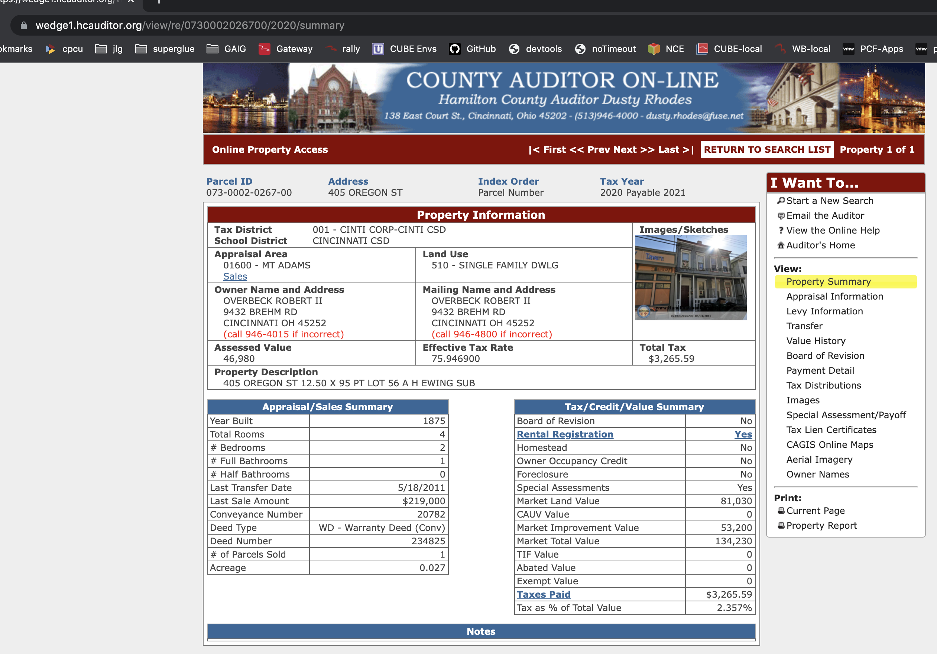

https://www.myheritage.com/names/james_gilvary

[James M. GILVARY, born Circa 1857](https://www.myheritage.com/names/james_gilvary)

**James M. GILVARY** was born circa 1857, in birth place, New York, to John GILVARY and Mary GILVARY (born FIFE).

John was born circa 1825, in Ireland.

Mary was born circa 1830, in Ireland.

**James** had 2 brothers: Joseph C. GILVARY and one other sibling.

**James** lived in 1880, in address, Ohio.

[John GILVARY, born Circa 1825](https://www.myheritage.com/names/John_Gilvary)

**John GILVARY** was born circa 1825, in birth place.

**John** married Mary GILVARY (born FIFE).

Mary was born circa 1830, in Ireland.

They had 3 sons: Joseph C. GILVARY and 2 other children.

**John** lived in 1880, in address, Ohio.

<https://www.johngrenham.com/surnamescode/grogeochart_full.php?surname=Gilvarry&search_type=full>

from John Loughney

Name John Gilvary  
Sex Male  
Age 65  
Death Date 10 Aug 1887  
Death Place Cincinnati, Hamilton, Ohio, United States  
Death Place (Original) Cincinnati, Hamilton, Ohio  
Marital Status Widowed  
Occupation Peddler  
Race White  
Father's Name Patrick Gilvary  
Event Type Death  
Residence Place Little Sisters of Poor  
Birth Year (Estimated) 1822  
Birthplace Donegal, Ireland